Name: Sapargali Temirlan
Group: SE-2403
Instructor: Kozhakhmet Zhaksylyk
PART 1
TASK 1
Deriverables
All deliverables such as foundry project is inside same directory as this document.
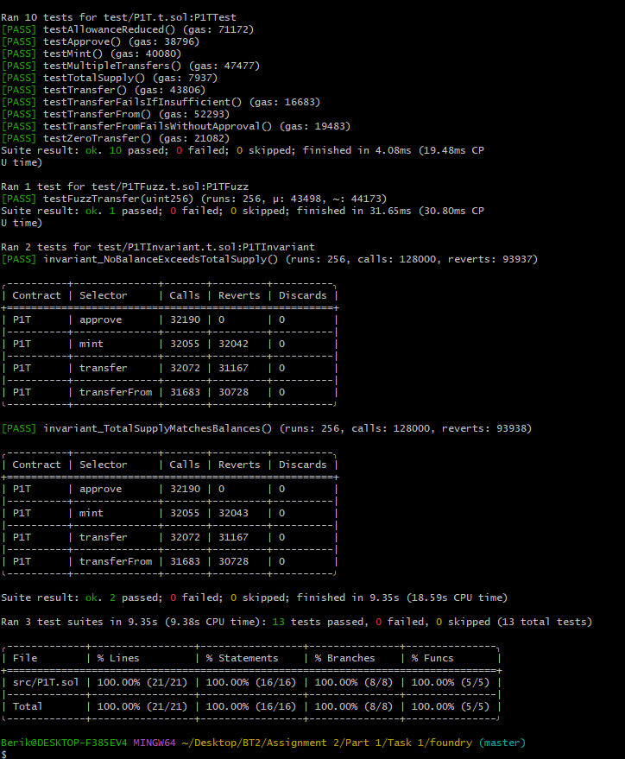
Fuzz testing: Testing a class/function with random or malformed input data.
Unit testing: Testing a class/function with deterministic user created input data and validating it using assertions.
TASK 2
Deriverables
All deliverables such as foundry project and the tests are inside the same directory as this document.
vm.createSelectFork
Creates a fork from a live network (mainnet/testnet)
Lets you interact with real deployed contracts
You can optionally specify a block number:
vm.createSelectFork(MAINNET_RPC_URL, 18_000_000);
Use when:
You want a fresh fork
You need deterministic state at a specific block
vm.rollFork
Moves the fork forward/backward to another block
vm.rollFork(18_000_100);
Use when:
You want to simulate time/block changes
Test behavior across different states
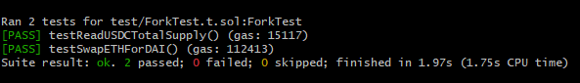
Benefits of Fork Testing
Interacts with real deployed contracts
No need to mock complex protocols (DEXs, lending)
High realism closer to production
Great for integration testing
Limitations
Requires RPC
State can change non-deterministic unless block pinned
External dependencies may break tests
Not ideal for pure unit logic

